bug report
HESBURGER app
ID number | #1
Name | Order payment security
Reporter | Armands
Submit Date | 04.03.21
Summary | Hesburger app after product selection and payment, choosing to PAY IMMEDIATELY, and choosing a PAYMENT CARD. By pressing a PAY. "The order has been shipped". No need to insert any PIN codes. This means that anyone can shop from my phone and spend the whole credit card.
URL | Hesburger app
Screenshot | Hesburger /Screenshot_1_Hesburger; Screenshot_2_Hesburger; Screenshot_3_Hesburger; Screenshot_4_Hesburger
Platform | Samsung Galaxy A5 (2017)
Operating System | Android 8.0.0
Browser | App (play veikals)
Severity | Major
Assigned to | /
Priority | High

Description
Hesburger app after product selection and payment, choosing to PAY IMMEDIATELY, and choosing a PAYMENT CARD. By pressing a PAY. "The order has been shipped". No need to insert any PIN codes. This means that anyone can shop from my phone and spend the whole credit card.

Steps to reproduce
> Open the Hesburger app
> Select a product
> add to cart
> Press PAY NOW and mark PAYMENT CARD
> Press to CONTINUE
> PRESS PAY
> And appears ORDER SENT

Expected result
Need to enter a PIN code or other authorization option.

Actual result
No need to insert any PIN code

Notes
Need check this option and to put insure payment security.
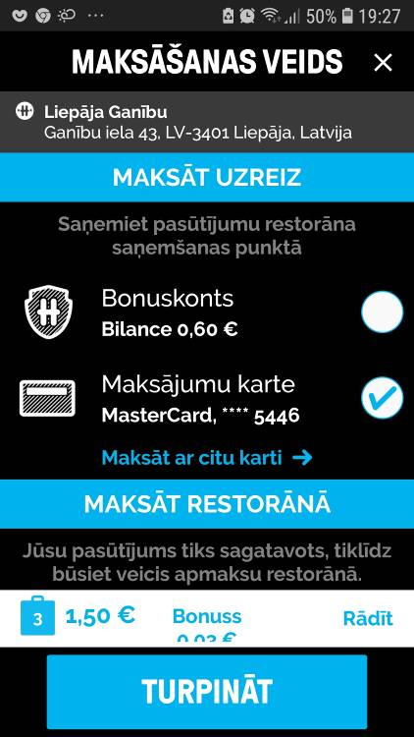
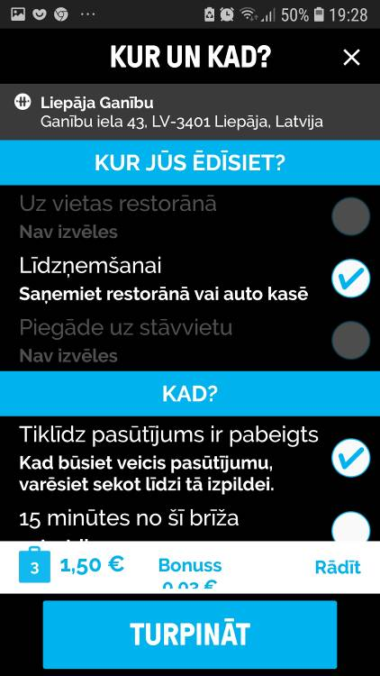
1 2

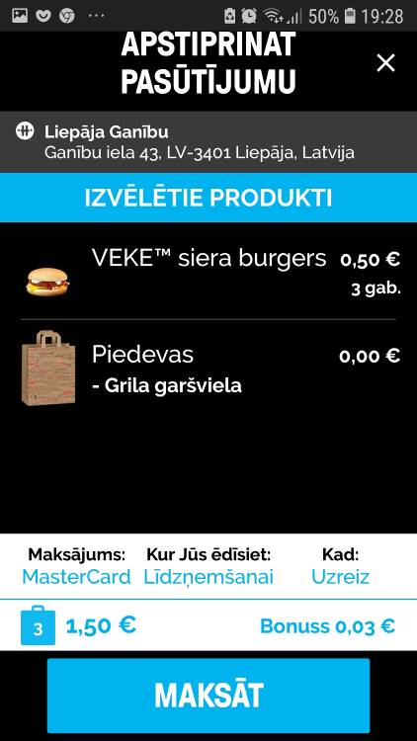
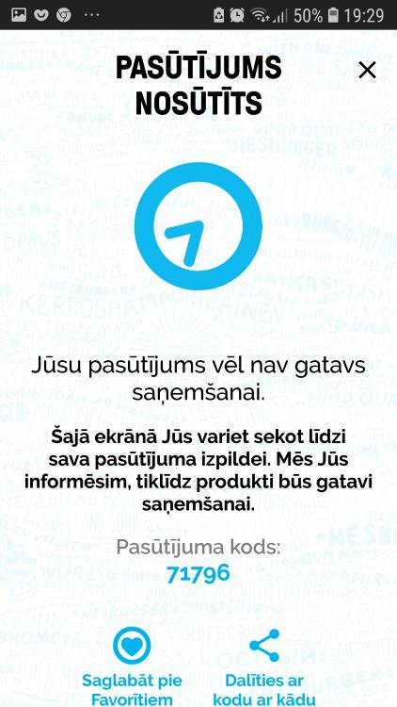
3 4

